**CSA0413 OPERATING SYSTEM**

**NAME:K.JYOTHI PRAKASH**

**REGNO:192111132**

Shell programs:

1.write a shell program to check the given number is even or odd

Program:

#!/bin/baash

echo "enter a number:"

read num

if((num%2==0));

then

echo "$num is even"

else

echo "$num is odd"

fi

output:

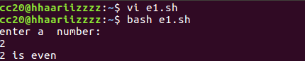

2.write a shell program to check the given year leap year or not

Program:

#!/bin/baash

echo "enter a year:"

read year

if((year%4==0));

then

echo "$year is leap year"

else

echo "$year is not a leap year"

fi

output:

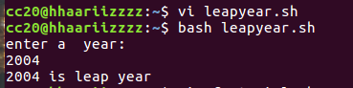

3.write a shell program to find the factorial of a number

Program:

#!/bin/baash

echo "enter a number:"

read num

factorial=1

for((i=1;i<=num;i++))

do

factorial=$((factorial*i))

done

echo "the factorial of $num is $factorial"

output:

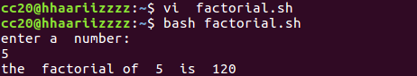

4.write a shell program to find sum of 100 numbers

Program:

#!/bin/bash

sum=0

for((i=1;i<=100;i++))

do

sum=$((sum+i))

done

echo "the sum of the first 100 natural number is $sum"

output:



5.write a shell program to make sum of digits

Program:

#!/bin/bash

# Function to calculate the sum of digits in a number

calculateSumOfDigits() {

num=$1

sum=0

while [ $num -gt 0 ]; do

digit=$((num % 10))

sum=$((sum + digit))

num=$((num / 10))

done

echo "Sum of digits: $sum"

}

# Read the number from the user

read -p "Enter a number: " number

# Call the function to calculate the sum of digits

calculateSumOfDigits $number

output:

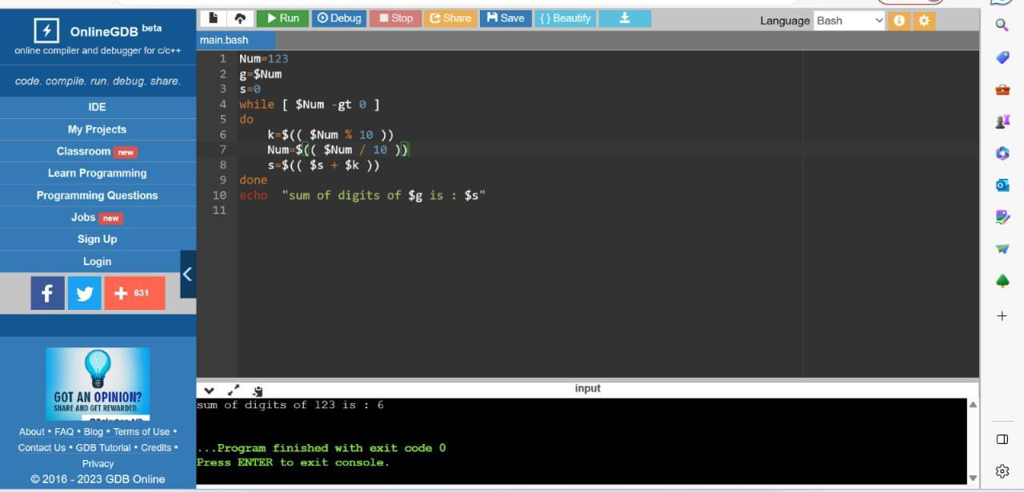

6.write a shell program to swap two numbes

Program:

#!/bin/bash

# Function to swap two numbers

swapNumbers() {

# Store the value of the first number in a temporary variable

temp=$1

# Assign the value of the second number to the first number

num1=$2

# Assign the value of the temporary variable to the second number

num2=$temp

echo "After swapping: Number 1 = $num1, Number 2 = $num2"

}

# Read the two numbers from the user

read -p "Enter Number 1: " num1

read -p "Enter Number 2: " num2

echo "Before swapping: Number 1 = $num1, Number 2 = $num2"

# Call the function to swap the numbers

swapNumbers $num1 $num2

output:

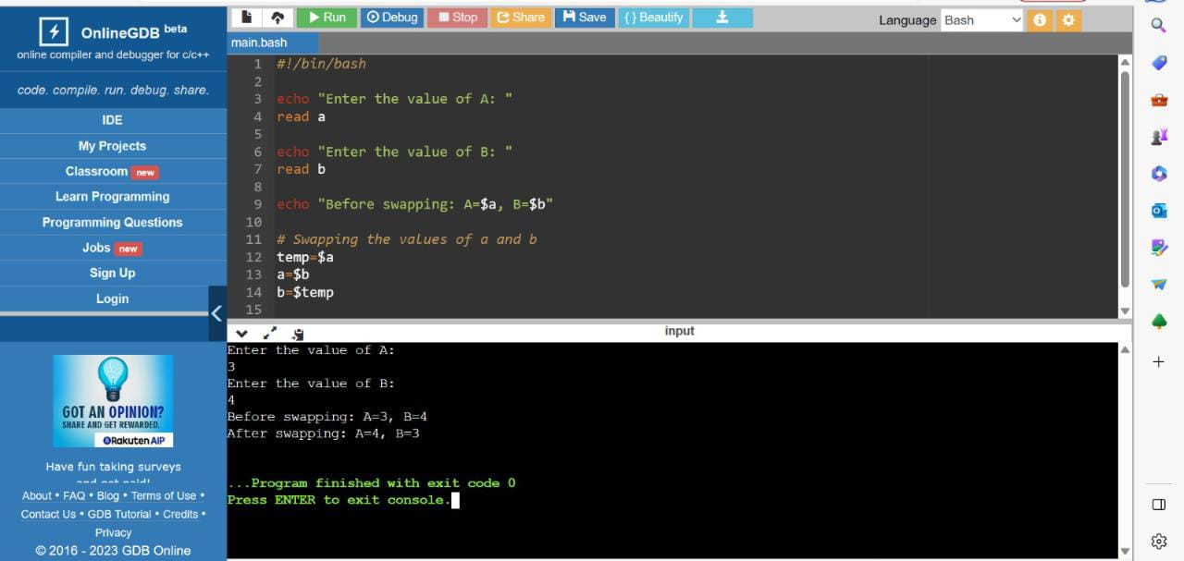

7.write a shell program to know greater number between two numbers

Program:

#!/bin/bash

# Function to find the greater number

findGreaterNumber() {

if [ $1 -gt $2 ]; then

echo "$1 is greater than $2"

elif [ $1 -lt $2 ]; then

echo "$2 is greater than $1"

else

echo "Both numbers are equal"

fi

}

# Read the two numbers from the user

read -p "Enter the first number: " num1

read -p "Enter the second number: " num2

# Call the function to find the greater number

findGreaterNumber $num1 $num2

output:

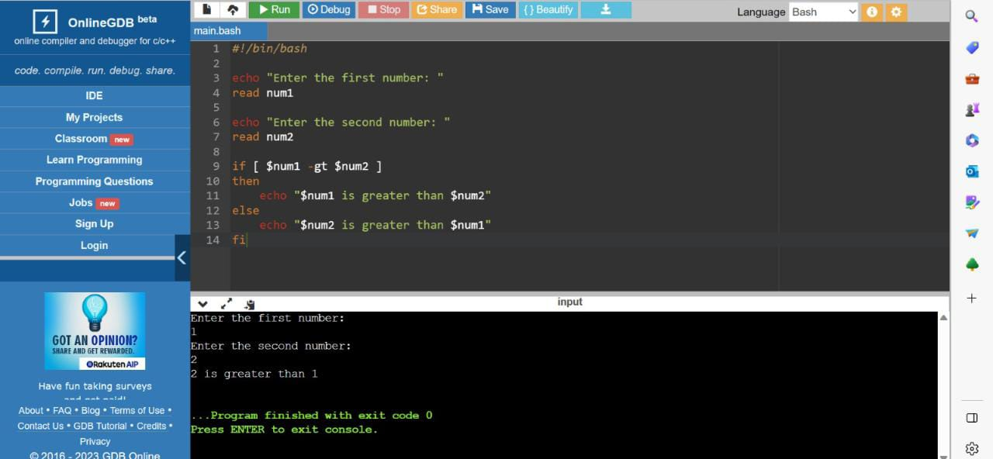

8.write a shell program to know greater number between three numbers

Program:

#!/bin/bash

# Function to find the greatest number among three numbers

findGreatestNumber() {

num1=$1

num2=$2

num3=$3

if [ $num1 -gt $num2 ] && [ $num1 -gt $num3 ]; then

echo "$num1 is the greatest number."

elif [ $num2 -gt $num1 ] && [ $num2 -gt $num3 ]; then

echo "$num2 is the greatest number."

else

echo "$num3 is the greatest number."

fi

}

# Read the three numbers from the user

read -p "Enter the first number: " number1

read -p "Enter the second number: " number2

read -p "Enter the third number: " number3

# Call the function to find the greatest number

findGreatestNumber $number1 $number2 $number3

output:

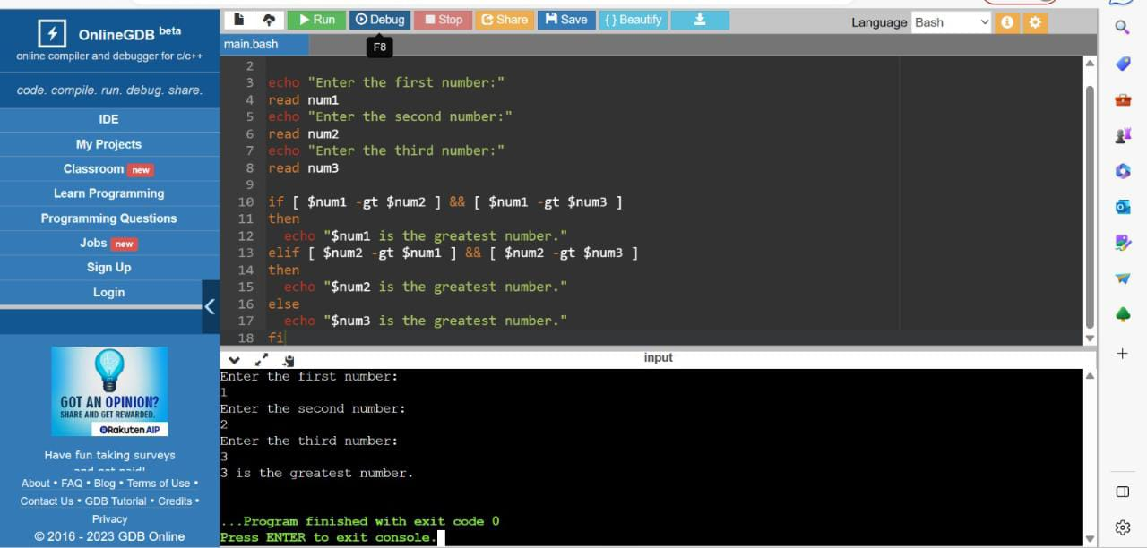

9.write a shell program for Fibonacci series

Program:

#!/bin/bash

# Function to generate Fibonacci series

generateFibonacciSeries() {

num=$1

# Handle the special cases for the first two Fibonacci numbers

if [ $num -ge 1 ]; then

echo -n "0 "

fi

if [ $num -ge 2 ]; then

echo -n "1 "

fi

# Generate the rest of the Fibonacci series

a=0

b=1

i=2

while [ $i -lt $num ]; do

next=$((a + b))

echo -n "$next "

a=$b

b=$next

i=$((i + 1))

done

echo

}

# Read the number of terms from the user

read -p "Enter the number of Fibonacci terms to generate: " number

# Call the function to generate the Fibonacci series

generateFibonacciSeries $number

output:

